# Laplace transform

1. Find the Laplace transform of the given function below:

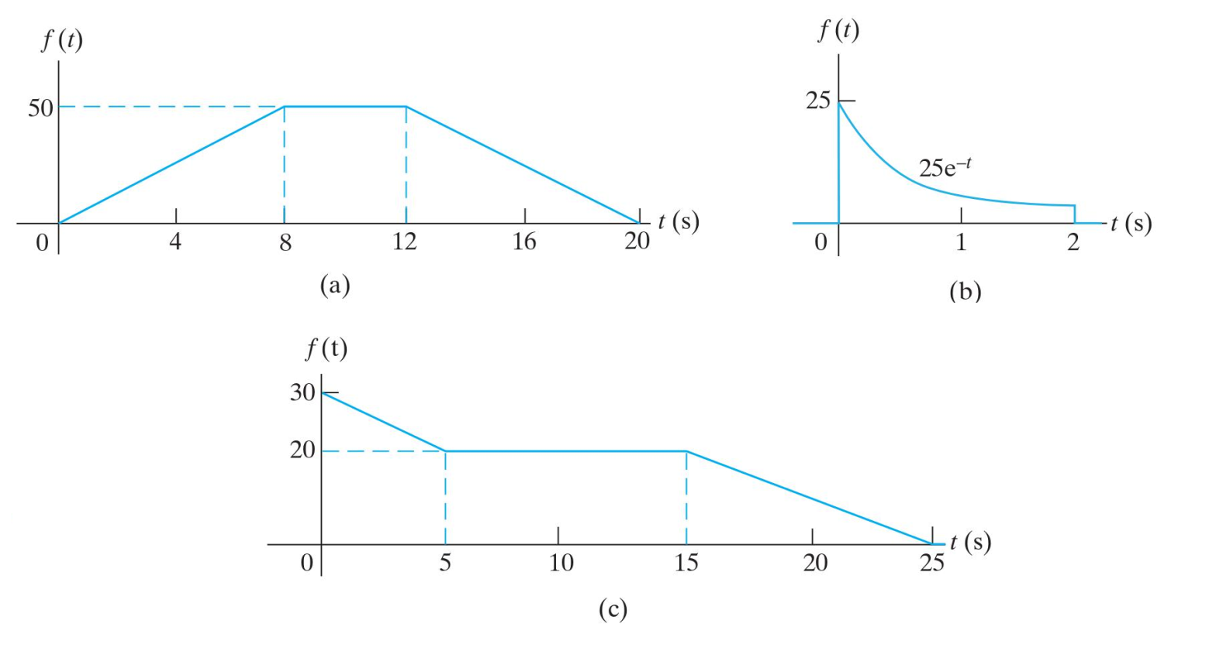

2. Find the inverse Laplace transform of the following function:

|  |  |
| --- | --- |
| $$a) F\left(s\right)=\frac{8s^{2}+37s+32}{(s+1)(s+2)(s+4)};$$ | $$b) F\left(s\right)=\frac{13s^{3}+134s^{2}+392s+288}{s\left(s+1\right)\left(s^{2}+10s+24\right)}$$ |
| $$c) F\left(s\right)=\frac{20s^{2}+16s+12}{\left(s+1\right)\left(s^{2}+2s+5\right)};$$ | $$d) F\left(s\right)=\frac{250\left(s+7\right)\left(s+14\right)}{s\left(s^{2}+14s+50\right)}$$ |
| $$e) F\left(s\right)=\frac{10s^{2}+28s+36}{\left(s+2\right)\left(s^{2}+2s+10\right)};$$ | $$f) F\left(s\right)=\frac{5s^{2}+9s+4}{s^{2}\left(s+4\right)}$$ |
| $$g) F\left(s\right)=\frac{s+4}{s^{2}+6s+9};$$ | $$h) F\left(s\right)=\frac{5s^{3}+20s^{2}-49s-108}{s^{2}+7s+10}$$ |

# Circuit analysis in S-domain

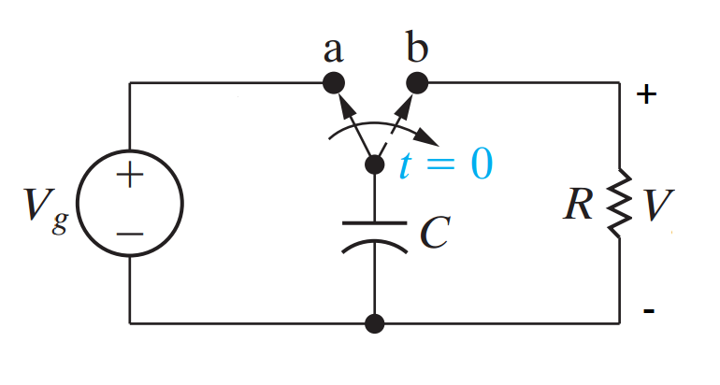1. The switch in the circuit in the Fig. 1 has been in the position (a) for a long time. At $t=0$, the switch moves instantaneously to position (b).

a) Construct and S-domain circuit for $t>0$.

b) Find $V(s)$.

c) Find $V(t)$.

Fig. 1

(You can use: $V_{g}=50V, C=500nF, R=1kΩ$)

# Butterworth filter design

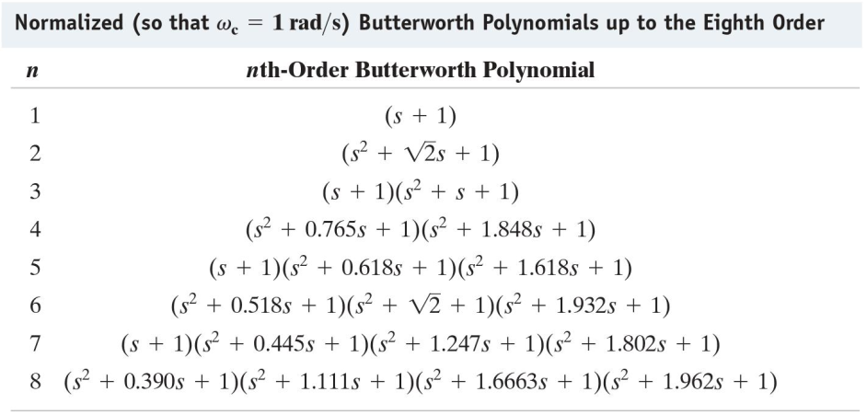1. Only using $1kΩ$ resistor, design a circuit that will implement the low pass Butterworth filter in which $f_{c}=2000Hz$. Construct the circuit diagram and label all the component values for each following cases:

a) $n=2$, Gain of 1.

b) $n=3$, Gain of 3.

c) $n=4$, Gain of 3.

d) $n=2$, Gain of 3.

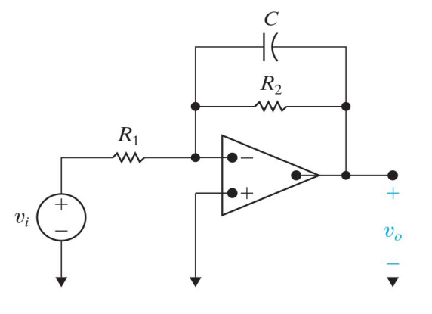2. Design an Op-amp based HPF with a cut off frequency of 4kHz and pass band gain of 8 using a 250nF capacitor

Fig. 2

a) Label the component value in Fig. 2 .

b) If the value of the feedback resistor is changed but the value of the resistor in forward path is unchanged. What characteristic of the filter is changed.

# Fourier series

1. Find the Fourier series of the function below:

